ASSIGNMENT-4.1
NAME: G.Abhilash H.T.NO:2303A52195
BATCH:35

Customer Email Classification
A company receives a large number of customer emails every day and wants to automatically classify them into the following categories:
- Billing
- Technical Support
- Feedback
- Others
Instead of training a new machine learning model, the company
decides to use prompt engineering techniques with an existing large language model.
Tasks
- Prepare five short sample emails, each belonging to one of the above categories.
- Write a zero-shot prompt to classify a given email into one of the categories without providing any examples.
- Write a one-shot prompt by including one labeled email example and ask the model to classify a new email.
- Write a few-shot prompt by including two or three labeled email examples and ask the model to classify a new email.
- Compare the outputs obtained using zero-shot, one-shot, and few-shot prompting techniques and briefly comment on their effectiveness.
CODE:

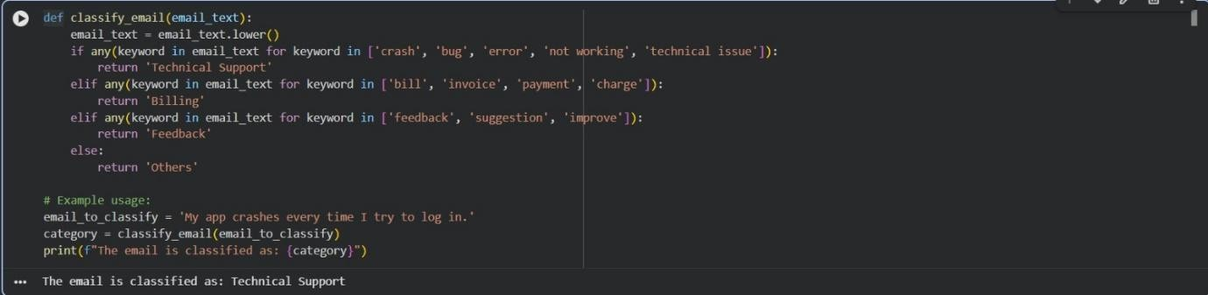

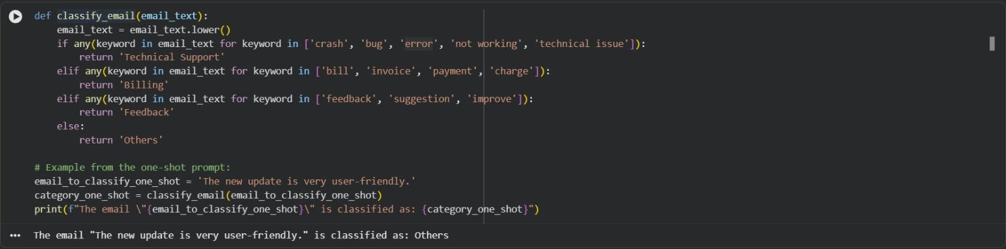

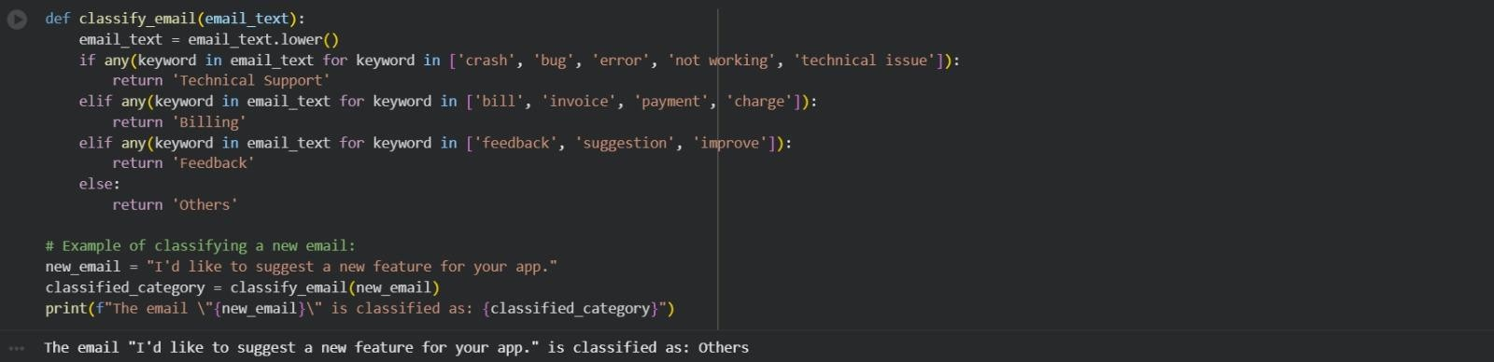

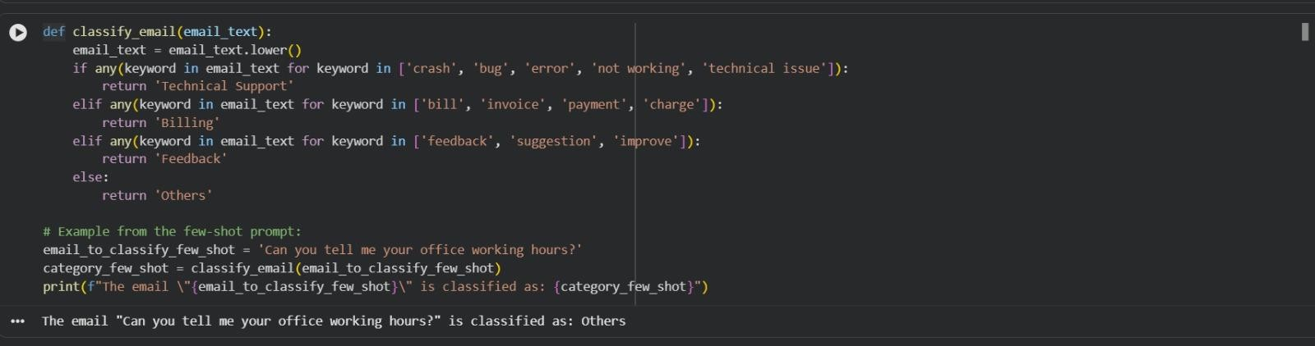
Intent Classification for Chatbot Queries
A company wants to deploy a chatbot to handle customer queries. Each query must be classified into one of the following intents:
Account Issue, Order Status, Product Inquiry, or General Question using prompt engineering techniques.
Tasks to be Completed
- Prepare Sample Data
Create 6 short chatbot user queries, each mapped to one of the four intents.

- Zero-shot Prompting
Design a prompt that asks the LLM to classify a user query into the given intent categories without examples.
- One-shot Prompting
Provide one labeled query in the prompt before classifying a new query.
- Few-shot Prompting
Include 3–5 labeled intent examples to guide the LLM before classifying a new query.
- Evaluation
Apply all three techniques to the same set of test queries and document differences in performance.
CODE:

